Proof of Interactions

Group Chat

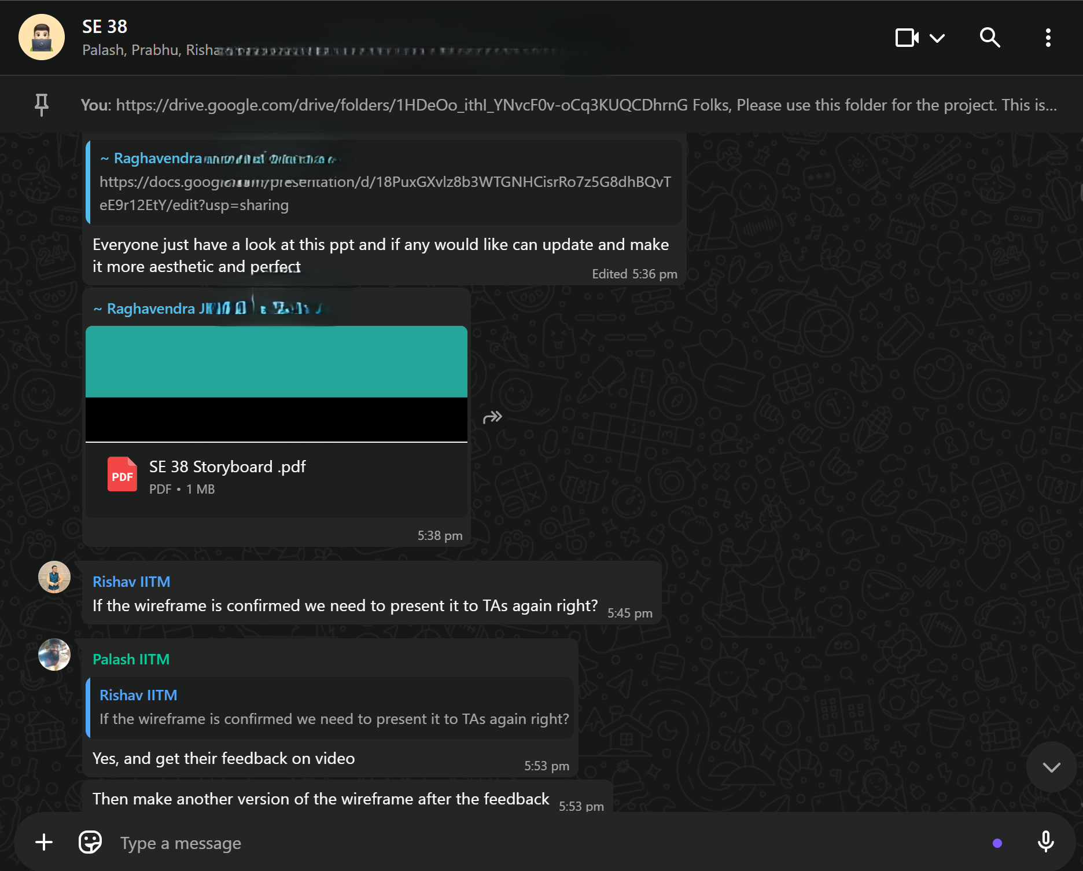

Interaction Meet recordings

Weekly Scrum calls
- Meeting Minutes
- October 6 - SCRUM call

